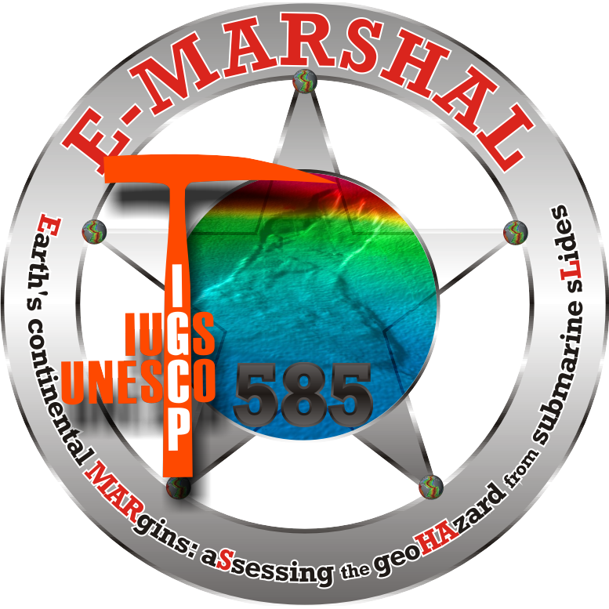
Second circular (http://landslide.jp)
5th International Symposium on Submarine Mass Movements and Their Consequences
(http://landslide.jp)

Symposium: 24th (Mon) - 26th (Wed), October 2011
Field excursions: 23rd (Sun) and 27th (Thu)–28th (Fri), October 2011
Kyoto University
The 5th International Symposium on Submarine Mass Movements and Their Consequences will be held on 24th - 26th, October 2011, in Kyoto, Japan. Field excursions will be organized on 23rd and 27th - 28th October to visit recent active landslide and impressive fossil outcrops of submarine mass movements (see details below). This symposium is part of the International Geoscience Programme IGCP-585, also known as E-MARSHAL project (http://www.igcp585.org), a joint endeavor of UNESCO and the International Union of Geological Sciences. The main objective of this event is to bring a world-wide perspective of submarine mass movements and their consequences by assembling state-of-the-art contributions from international researchers of academic institutions and the offshore industry, and to stimulate the research in Asian countries. This symposium provides full coverage of the scientific and engineering aspects of this type of marine and coastal geo-hazards.

(A) Conference Themes:
- Submarine landslides in active margins vs. passive margins
- Geologic and tectonic controls on submarine landslides
- Sequential stratigraphic significance of submarine landslides
- Impact of mass transport deposits and slope failure on offshore operations
- Seismic activity related to submarine landslides
- Landslide tsunamis
- Significance of gas hydrates in submarine slope failure
- New tools for investigation of submarine slope failures and ocean drilling
- Geotechnical investigation of submarine slopes
- Risk and hazard assessment of submarine landslides
- Relevance of climate change in submarine slope instability
- Analogue and numerical modeling approaches of submarine mass movements

(B) Keynote Speakers:
Opening Keynote Speech:
Kyoji Sassa (Executive Director of International Consortium on Landslides)

Introductory note on IGCP585:
Roger Urgeles (Institut de Ciències del Mar (CSIC))

Thematic keynotes:
Brandon Dugan (Rice University, USA)
Andrew Lin (National Central University , Taiwan)
Farrokh Nadim (Norwegian Geotechnical Institute, Norway)
Gian Andrea Pini (University of Bologna, Italy)
Kenji Satake (University of Tokyo, Japan)
(alphabetical order)

(C) Venue and Dates:
Shiran Kaikan Yamauchi Hall, Kyoto University, Kyoto, JAPAN
Symposium: 24th (Mon) - 26th (Wed), October 2011
Field excursions: 23rd (Sun) and 27th (Thu)–28th (Fri), October 2011

(D) Symposium schedule
23rd (Sun): Pre-field excursion and icebreaker,
24th (Mon): Registration, morning and evening sessions and keynote speeches,
25th (Tue): Registration, morning and evening sessions and keynote speeches,
26th (Fri): Registration, morning and evening sessions and keynote speeches,
(There will be a social dinner during the symposium, during which the best poster and the best paper will be awarded)
27th (Sat)-28th (Sun): Post-field excursion

(E) Official language:
English

(F) Field Excursions (http://www.landslide.jp/field.shtml):
(1) Pre-field excursion, One day field trip to Active Landslides in Osaka (23 October, 2011)
Tentative schedule: 8:00 Participants meet at JR Kyoto Station. 8:30 Depart Kyoto Station by bus, 11:00-15:00 Lunch and Field observation, 17:30 Arrive Kyoto
Fee: ~6000 yen

(2) Post-field excursion, Two day field trip to Pleistocene Submarine Landslides in the Boso Region (27-28 October, 2011)
Tentative schedule:
27 Oct. 8:00 Participants meet at JR Kyoto Station, 8:30 Depart the Kyoto station of Shinkansen (Super express train), 11:00 Arrive at the Tokyo station and drive to Boso by bus, Lunch, 13:00-17:00 Field observation (Stop 1: Submarine landslide associated with earthquake-induced liquefied sediment flow; Stop 2: chaotic rock body apparently due to methane explosion), 17:30 arrive at Hotel.
28 Oct. End of the field trip. The bus will stop at Haneda International Airport and JR Tokyo station around noon (about 2 hours to Narita International Airport by shuttle bus or train, about 1 hour flight or ~3 hours by Shinkansen to Kansai International Airport,. Transportation fee from Haneda Airport or Tokyo station to Narita, Kansai or any other destination is not included in the field trip fee.
Fee: ~35000 yen

Further field trip details will be announced on the conference website (http://landslide.jp) later.

(G) Registration
Until 1 April, 2011, Early bird 55,000 Jpn yen (student 25,000 yen)
After 1 April, 2011, Regular fee 65,000 Jpn yen (student 30,000 yen)
The registration system will be soon set up on our website (http://landslide.jp).
The registration fee includes an icebreaker, an official dinner party, lunch meals, coffee breaks and the Springer book.

Cancellation policy
50% refund on registration fees on all cancellations made before 15 May, 2011 (cancellations will still receive the book with the conference articles). Please, for additional questions contact info@landslide.jp

Student support
We are planning to establish a series of grants for students and participants from developing countries to attend the conference. Grant information will be soon displayed on our website and will also be sent to symposium participants as soon as it becomes available.

Accommodation
There are many hotels in Kyoto from 5000 yen to 50000 yen. Additional hotel information will be soon displayed on our website (http://landslide.jp).

Entry Visa
If you need an invitation letter for visa application, please contact us (info@landslide.jp) and we will get back to you with a customized letter.

(H) Abstract submission:
Please visit <http://landslide.jp> and submit your less than 300 words abstract by 14th, October 2010. Authors should suggest the name of 4 potential reviewers that have agreed to review their papers in advance.
Authors of abstracts submitted before this deadline have the possibility to submit a full-paper manuscript for a book published by Springer (see below), following the three successful earlier volumes. Abstracts that do not intend to submit a full paper may do so until September 1st 2011.
(I) Conference Publication:
For this symposium, a book will be published by Springer as the fourth volume of the successful publication series ‘Submarine Mass Movements and Their Consequences’. This book contains peer reviewed papers submitted in advance of the conference, and will be distributed to the conference participants upon registration. The two previous volumes are indexed in the ISI Web of Knowledge.
For a glimpse of the third volume, please visit:
http://www.springerlink.com/content/j1wp66/
(J) Climate and Travel Information
See http://www.kyoto.travel/

(K) Important dates:
- 14 Oct. 2010: Deadline for abstract submission (with intention to submit a full paper). Authors suggest the name of 4 potential reviewers that have agreed to review the paper in advance.
- 15 Nov. 2010: Notification of acceptance (or rejection) of abstract and the names of reviewers confirmed by editors
- 15 Nov. 2010 - 01 Apr. 2011: Author’s working period (see below for author’s responsibility in this period).
- 01 Apr. 2011: Author's deadline of final (corrected) papers submitted to editors with revision notes (must be accompanied by an early bird registration). Reviewers obligatorily appear on the acknowledgments. Author’s preference on Oral/Poster presentations*.
- 01 Sep. 2011: Final deadline for Poster abstract submission (no full-paper submission) *.
*Authors of full-papers have preference in presenting their work orally
Authors' responsibility during the working period (15 Nov. 2010 - 01 Apr. 2011):
- Production of full-paper manuscript
- Manuscript submission to reviewers and editors, no later than 15 Feb.
- Receive solicited corrections and signed forms from reviewers, no later than 15 Mar. Authors must report this to the editors.
- Appropriate revision works after reviewer’s comments
- Submission of revised manuscript (with reviewers’ notes and forms) to the editors, no later than 01 Apr.

(L) For additional information contact:
info@landslide.jp

(M) Organizing committee:
Yasuhiro YAMADA (Chair; Kyoto University),
Kiichiro KAWAMURA (Secretary; Fukada Geological Institute)
Juichiro ASHI (Atmosphere and Ocean Research Institute, University of Tokyo)
Ken IKEHARA (AIST, Geological Survey of Japan),
Katsumi KAMEMURA (Fukada Geological Institute)
Toshiya KANAMATSU (JAMSTEC)
Arito SAKAGUCHI (JAMSTEC)
Shinji SASSA (Port and Airport Research Institute)
Takae TAKAGI (Fukada Geological Institute)
Takeshi TSUJI (Kyoto University),
Koji YAMAMOTO (JOGMEC)
Yuzuru YAMAMOTO (JAMSTEC)
International Advisory board:
Roger URGELES (Institute of Marine Sciences (CISC), Spain)
David MOSHER (Natural Resources Canada - Geological Survey of Canada, Canada)
Jason CHAYTOR (USGS - Woods Hole, USA)
Michael STRASSER (MARUM, Bremen University, Germany)
Jacques LOCAT (Laval University, Canada)
Norio OYAGI (Fukada Geological Institute, Japan)
Kyoji SASSA (Kyoto University, Japan)
Symposium Supporters:
- IGCP project 585
- International Union of Geological Sciences
- UNESCO
- Integrated Ocean Drilling Program- Management International (IODP-MI)
- Geological Society of Japan (Co-hosting)
Society of Exploration Geophysicists of Japan
- The Japanese Geotechnical Society
- Japan Association for Quaternary Research
- The Sedimentological Society of Japan
- Japan Society of Engineering Geology
- Japan Society for Active Fault Studies
- The Japan Landslide Society
- Seismological Society of Japan
- Japan Society of Civil Engineers
- Japanese Committee for Rock Mechanics
Further announcements on the symposium will be circulated via the website <http://landslide.jp>. Contact address is “info@landslide.jp”.
Invitation Message from IGCP-585 Chairs,
Dear colleagues,

IGCP-511 to IGCP-585

The very successful IGCP project 511 (Submarine Mass Movements and Their Consequences) has ended and IGCP project 585 (E-MARSHAL: Earth’s continental MARgins: aSsessing the geoHazard from submarine Landslides) has begun. Project 585 will continue to support submarine landslide research and October, 24 to 26, 2011 will mark the occasion of the 5th “International Symposium on Submarine Mass Movements and Their Consequences”. The four previous successful events in Nice (France), Oslo (Norway), Santorini Is. (Greece) and Austin, TX (USA) were organized in the frame of project IGCP-511 and this year will represent the passage to the recently funded IGCP-585, supported by International Union of Geological Sciences (IUGS) and the United Nations Educational Scientific and Cultural Organization (UNESCO). During the five years of Project 511, the “submarine landslides” community grew both in terms of origin of affiliates and themes being challenged. In 2011, the “International Symposium on Submarine Mass Movements and Their Consequences” moves to Kyoto (Japan) and without a doubt this will further enlarge the size of this forum and our community. The conference will include various themes in relation to submarine landslides, such as process understanding, gas hydrates, earthquakes, new tools and techniques, hazard and risk estimation and relation to climate change that will be led by keynote lectures from the most prominent scientists in our community. In addition we will have our panel debates in various “hot topics” of submarine landslide research. We expect this will contribute to significant knowledge transfer in the various themes proposed by the conference. We also hope that this will be an important opportunity for exciting new ventures in “Submarine Landslides Research”.

We hope to meet you all in Kyoto!

IGCP-585 chairs
Roger Urgeles, CSIC, Barcelona, Spain
David Mosher, GSC, Halifax, Canada
Jason Chaytor, USGS, Woods Hole, USA
Michael Strasser, MARUM, Bremen, Germany

